Volume: 1 • Issue: 1 • Article ID: 2126-0621-7392 • DOI: 10.64823/{journalSlug}.{doiValue}
Article Title Goes Here: A Concise, Specific, and Descriptive Heading
First A. Author ¹, Second B. Author ², Third C. Author ^{1,*}
¹ Department, Institution, City, Country
² Department, Institution, City, Country
* Corresponding author: author@institution.edu • ORCID: 0000-0000-0000-0000 (optional)
Abstract
The abstract is a single, unstructured paragraph of 150–250 words that states the problem, the approach, the principal results, and the main conclusion. It should be self-contained, contain no citations, undefined abbreviations, or references to figures and tables, and should allow a reader to grasp the contribution without reading the full article. This sample text demonstrates the IORO Abstract Body style inside the shaded abstract box.
Keywords: keyword one; keyword two; keyword three; keyword four; keyword five

- Introduction
The introduction establishes the context and motivation, states the research problem and its significance, summarises the gap in existing knowledge, and ends with the specific objectives or contributions of the paper. In-text citations follow the IEEE numeric style, with bracketed numbers in order of first appearance [1]. Multiple sources may be grouped [2], [3].
Every paragraph in the article body uses the single “IORO Body” style. Authors should never apply manual font changes, manual line spacing, or manual spacing before/after paragraphs; all of these are controlled by the style definitions so that production and XML conversion remain fully automated.
- Literature Review
This section surveys and critically synthesises prior work, organised thematically rather than as a list of summaries. It should make explicit how the present study extends, challenges, or fills a gap in the cited literature [4], [5].
  - A Subsection Heading
Subsections use Heading 2 and are numbered automatically as 2.1, 2.2, and so on. A third level (Heading 3) is available for finer structure and renders in bold italic.
  - Lists, Quotations, and Notation
Bulleted lists use the “bullets” list and support sub-items. Apply the list, never type bullet characters by hand:
- First-level bullet item.
  - Second-level sub-bullet (en dash).
    - Third-level sub-bullet (hollow circle).
- Another first-level item.
Numbered lists use the “numlist” list, which nests as 1 → a → i:
- First numbered step.
  - Lettered sub-step.
    - Roman-numeral sub-sub-step.
- Second numbered step.
Long verbatim passages use the block-quote style — indented, italic, with a left rule:
A block quotation is set off from the main text so the reader can see at a glance that the words are quoted. It carries its own indent and left accent rule, and omits quotation marks.
Inline notation is also supported: italic for terms and non-English words such as Vipatra, monospace for code or identifiers such as model.fit() , subscripts such as H₂O, superscripts such as x², and footnotes for asides.
- Methodology
The methodology describes the design, data, and procedures in enough detail to permit replication. Variables, instruments, and analytical techniques should each be defined precisely.
Table 1. Summary of experimental parameters.
Parameter | Setting | Unit
Sample size | 240 | participants
Learning rate | 0.001 | —
Epochs | 50 | iterations
Equations are created with the Microsoft Equation Editor and centred, with a right-aligned equation number in parentheses, as shown in Eq. (1).
$σ(x) = \frac{1}{1 + e^{−x}}$ | (1)
- Results
Results are reported objectively, without interpretation, using figures and tables to present data concisely. Each figure is embedded immediately after its first citation in the text, and the caption is placed below the figure, as in Fig. 1.
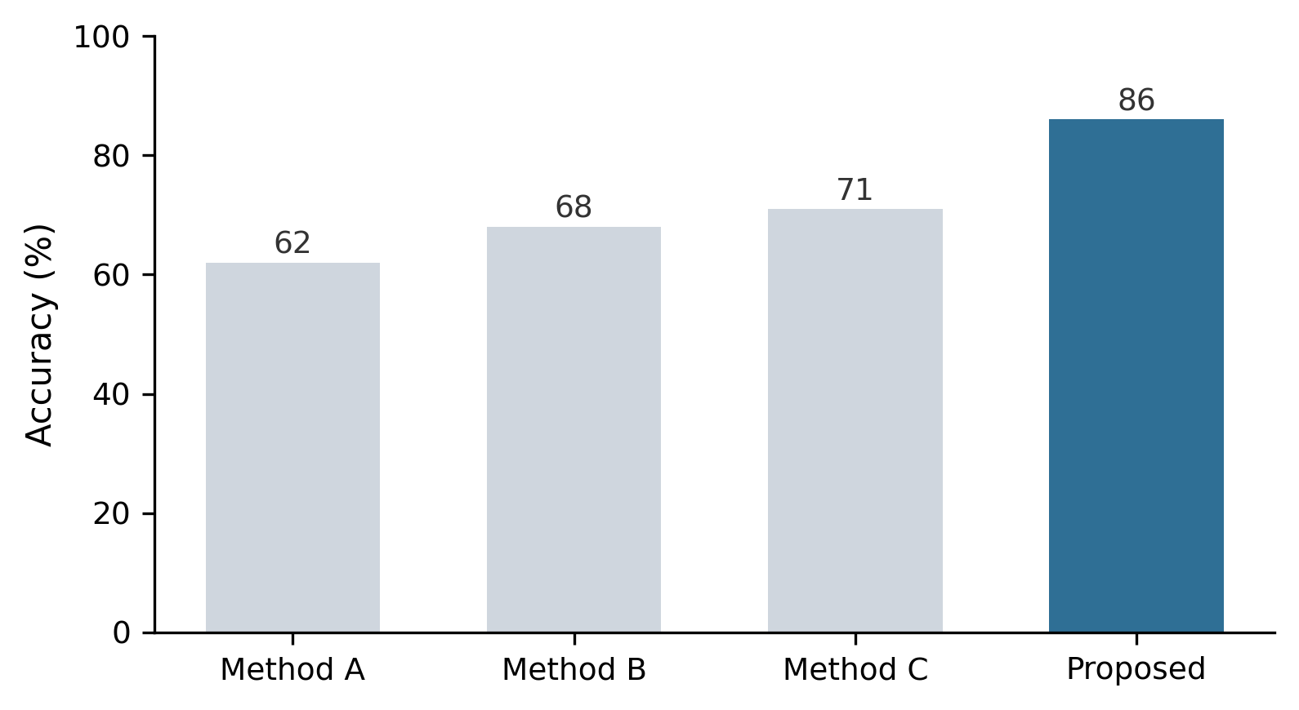
Fig. 1. Comparative accuracy of baseline methods against the proposed approach. Captions are placed below the figure and use the IORO Figure Caption style.
- Discussion
The discussion interprets the results in light of the research questions and prior literature, addresses limitations honestly, and avoids overstating causal claims beyond what the design supports.
- Conclusion
The conclusion restates the principal contribution, summarises the key findings without repeating the results verbatim, and points to concrete directions for future work.
Acknowledgements
Optional. Acknowledge non-author contributors, facilities, or administrative support here.
Funding
State all sources of funding with grant numbers, or declare: “This research received no external funding.”
Conflict of Interest
Declare any financial or non-financial competing interests, or state: “The authors declare no conflict of interest.”
Data Availability Statement
State where the data supporting the findings are available, including repository name and accession/DOI, or explain any access restrictions.
AI Usage Disclosure
Disclose any use of generative AI or AI-assisted tools in the preparation of the manuscript, including the tool, version, and purpose. AI tools must not be listed as authors. Example: “The authors used [tool/version] for language editing; all content was reviewed and verified by the authors.” If none was used, state: “No generative AI tools were used.”
Author Contributions
Use CRediT roles, e.g.: Conceptualization, A.A. and B.B.; methodology, A.A.; analysis, C.C.; writing—original draft, A.A.; writing—review and editing, all authors. All authors have read and agreed to the published version of the manuscript.
References
- A. B. Author and C. D. Author, “Title of the journal paper,” Journal Name, vol. 12, no. 3, pp. 45–60, 2024, doi: 10.0000/xxxx.
- E. F. Author, Title of the Book, 2nd ed. City, Country: Publisher, 2023.
- G. H. Author, “Title of the conference paper,” in Proc. Int. Conf. on Topic, City, Country, 2023, pp. 112–119.
- I. J. Author et al., “Title of the article,” Journal Name, vol. 8, no. 1, pp. 1–15, 2022.
- Organisation, Title of the Report, City, Country: Publisher, 2021. [Online]. Available: https://example.org/report
Appendix A. Supplementary Material
Optional. Place supporting derivations, extended tables, or questionnaire instruments here. Appendix items are labelled A.1, A.2, etc.
© 2026 The Author(s). Published by IORO Publications under a Creative Commons Attribution 4.0 International (CC BY 4.0) licence.

Footnotes appear at the foot of the page and are numbered automatically. Use them sparingly for clarifications that would interrupt the main text.

